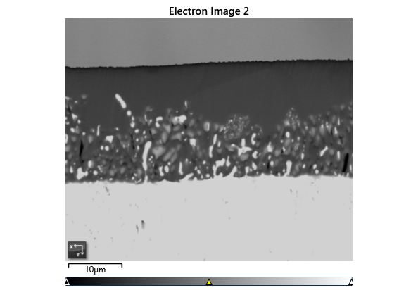

Settings

|  |  |
| --- | --- |
| Accelerating Voltage | 20.00 kV |
| Specimen Tilt (degrees) | 70.00 ° |
| Hit Rate | 78.26 % |
| Speed of Acquisition | 24.35 Hz |

Phases for Acquisition

|  |  |  |  |  |  |  |  |  |
| --- | --- | --- | --- | --- | --- | --- | --- | --- |
| Phase | a | b | c | Alpha | Beta | Gamma | Space Group | Database |
| Iron bcc (old) | 2.87 Å | 2.87 Å | 2.87 Å | 90.00 ° | 90.00 ° | 90.00 ° | 229 | HKL |
| Iron fcc | 3.66 Å | 3.66 Å | 3.66 Å | 90.00 ° | 90.00 ° | 90.00 ° | 225 | HKL |
| Nickel | 3.52 Å | 3.52 Å | 3.52 Å | 90.00 ° | 90.00 ° | 90.00 ° | 225 | OINA Phases |

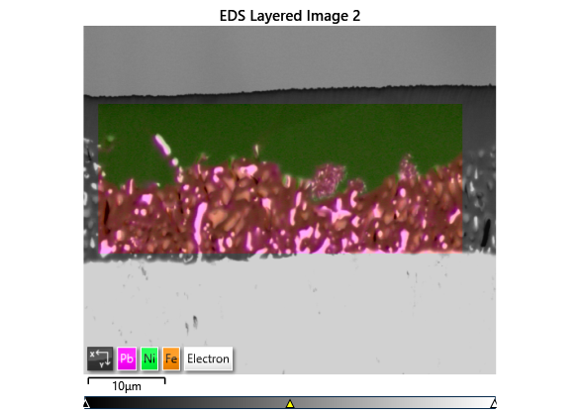

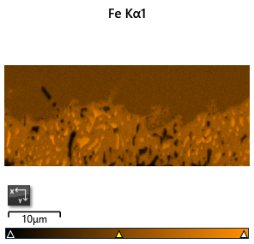

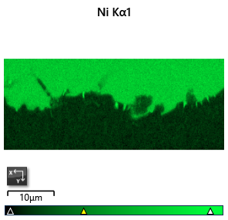

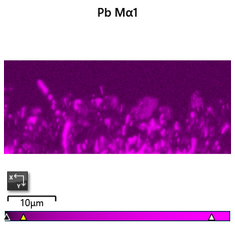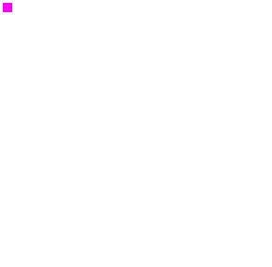

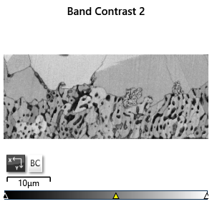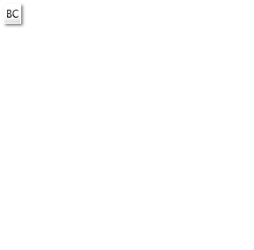

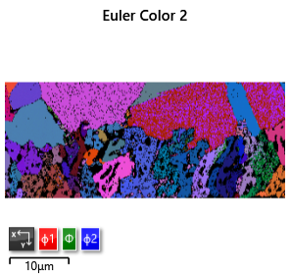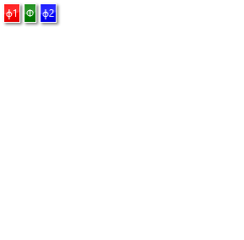

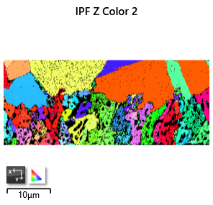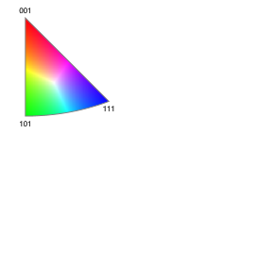

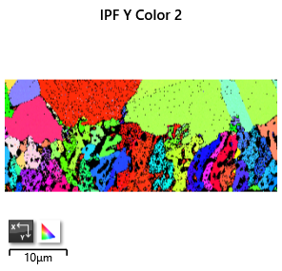

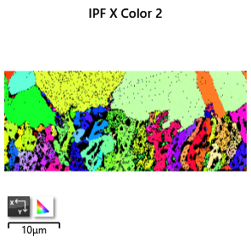

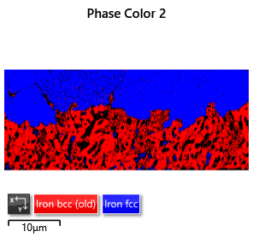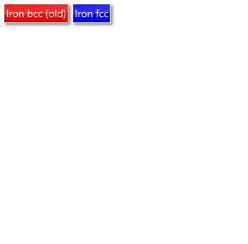

Phase Fraction

|  |  |  |  |  |  |  |  |  |  |  |
| --- | --- | --- | --- | --- | --- | --- | --- | --- | --- | --- |
| Phase Name | Phase Fraction (%) | Phase Count | Mean Band Contrast | Standard Deviation Band Contrast | Min Band Contrast | Max Band Contrast | Mean MAD | Standard Deviation MAD | Min MAD | Max MAD |
| Iron bcc (old) | 34.86 | 15390 | 94.73 | 12.46 | 16.00 | 126.00 | 0.86 | 0.29 | 0.22 | 2.00 |
| Iron fcc | 43.40 | 19160 | 102.53 | 10.31 | 27.00 | 130.00 | 0.74 | 0.22 | 0.15 | 2.00 |
| Nickel | 0.00 | 0 | 0.00 | 0.00 | 0.00 | 0.00 | 0.00 | 0.00 | 0.00 | 0.00 |
| Zero Solutions | 21.74 | 9595 | 63.54 | 28.78 | 0.00 | 138.00 |  |  |  |  |